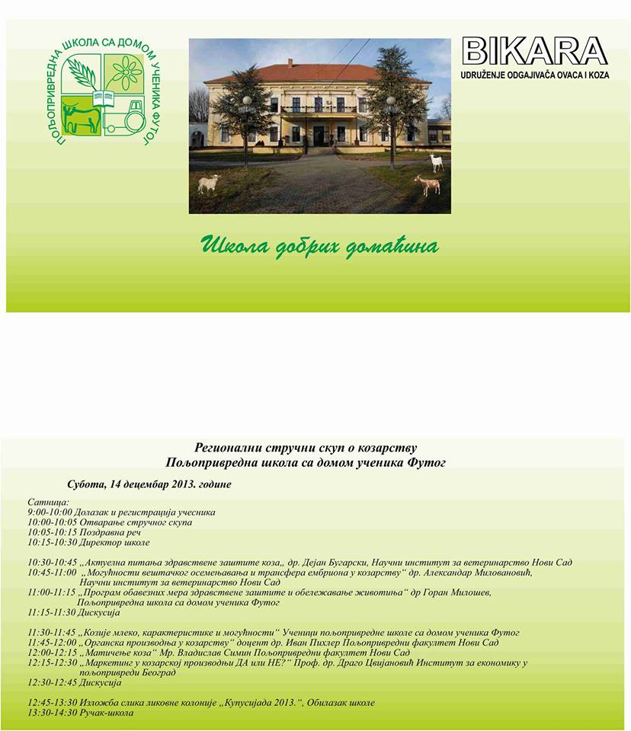
Organized by the Association of Sheep and Goats Breeders “BIKARA” and the Agricultural School with dormitory Futog, on 14th December 2013 in the secondary agricultural school with dormitory Futog, was held a regional scientific meeting on goat breeding. At the meeting took his part Professor Drago Cvijanovic, Ph.D., Director of the Institute of Agricultural Economics, on the subject “marketing in goat production, yes or no?”

